Bryan Cabrera

Module 1.2 Assignment

5/31/2024

**Link:** <https://github.com/Bryan-Cabrera/CSD340.git>

**Screenshots:**

-Local directory

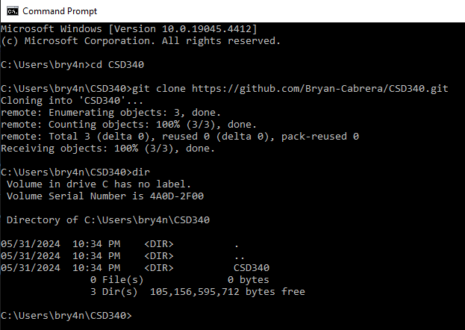

-Github landing page

